**Subject:** WEB DEVELOPMENT – LEC Class

**Activity:** FINAL EXAMINATION

**Name: BERNARDO Allan C.**

**Section: BSIS 3A**

**Score: ____ / 100 Rating: ____ %**

**INSTRUCTIONS:**

1. Do not copy and paste answers from your classmates/internet
2. Avoid plagiarism. Plagiarism is a form of cheating.
   1. Explain based in your own understanding (questions 1 to 5)
3. Answers can be done using word processor (questions 1 to 5).
   1. If you are using pen and paper, please ensure that the images are clear when you upload them. Image layout should be portrait (not landscape!) and not blurred.
4. Question #6 output are: screenshot and code

QUESTIONS:

1. If you were to chose a Web Dev career, what will be your ideal career? What do see yourself? (10 pts)

* If I entered in the IT industry after my college. I will pursue myself as backend developer to my first path. Because if you handle the backend its easy to apply the front end like HTMLS, CSS AND JavaScript.

1. Explain the difference between the different types of web development career. (10 pts)

* **Front End Engineer** - “Front end” includes all customer-facing features of a website or app: text fields, images, buttons, and banners. These engineers program the interface users engage with. HTML, CSS, and JavaScript are all front-end coding languages.
* **Back End Engineer** - Back-end engineers build the mechanics of how a site processes information. They determine how the site will communicate with servers, and how to collect, store and manage user data. Ruby, PHP, and Python are some of the most common languages for back-end development.
* **Full Stack Engineer** - If you know multiple languages and have successfully built both front and back ends of a site, congrats: you’re a full stack engineer. These expert programmers can guide the user flow, as well as how the data is transmitted to servers.
* **Software Architect** - An experienced programmer who leads the development team. They make high-level decisions about design and functionality and create standards and tools for the department.

1. What will be the skillsets that you will need in each of these types? (10 pts)

* If I go to the front end career. I will study HTML, CSS, AND JAVASCRIPT and some front end frameworks like bootstrap, react etc.
* If I go to the back end career. I wil study one of the back end language like php, python, and javascript etc.
* For full stack career. I will study both front end and backend technologies to create full pledge application.
* For software architect this is the way on how to lead a team for a project. Meaning all technologies that used to develop application you know how to use.

1. Briefly explain, in your own words, the importance of HTML and CSS in web design? Do we still need these tools? (10 pts)

* As we all know, If you become a developer in specific company. You need to understand HTML and CSS for web design, because it is a tool that we need to study because all developers use HTMLs and CSS to create a web applications. Html and CSS is used when you request an http to a server.

1. Why do you think we need to study these tools? Are these important in your web dev career? (10 pts)

* I think yes, Because HTML AND CSS is a structured of the web. When open a website that is created by htmls and css for styling the web. That’s why it is important to learn. At the end the day you will become a developer to develop and maintain web application.

1. 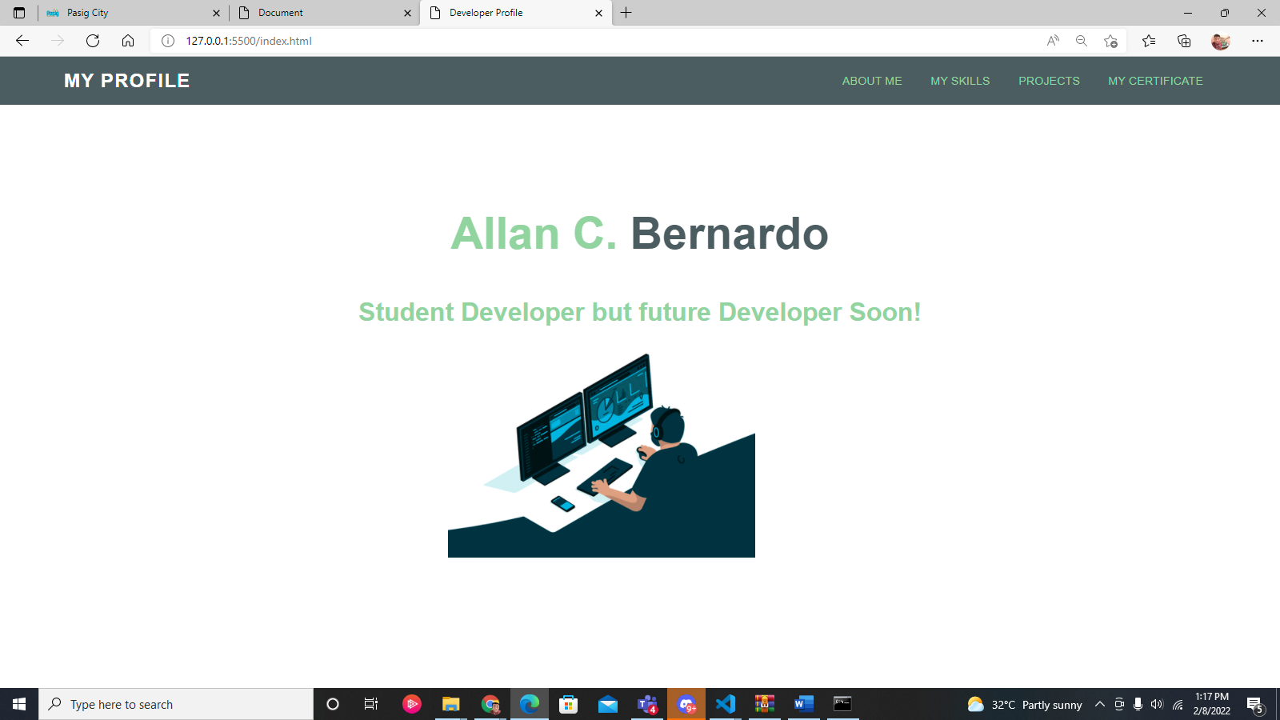Design an ***About Me*** web page of yourself using HTML & CSS. (50 pts) See the examples below:

